Web Design Final Project Plan

Matthew Lowe

Website Name: National Celeste

Purpose: “Your ONE STOP SHOP for Elites Only Democracy”

Site Description:

Let me start this by saying *this is a satire project*. Obviously, I have my own opinion on the 2020 election, but this final project isn’t a platform for my opinion. It’s more a Frankenstein of every “mainstream conspiracy theory” (depending on who you ask) around the elections: Russian interference, mail voting, and Dominion software. I want something that can make most people on both sides laugh about how absurd everything is. Contradictions and lapses in logic are intentional. If you have any questions on my intentions behind this website, refer to the listed competitors: Heavensgate.com, DHMO.org, and Thisman.org. Anyway, let’s get to the actual description.

National Celeste (NC) is a fictious nonprofit organization with a mission of creating elites only democracy. Their belief is most people, “the rabble” if you will, are incapable of running a government. Clearly a working-class person, who spends all day just trying to make a living, has no time for intellectual discussions. Only people with time and money to burn could be expected to do that. Their mission is to give every elite the confidence that when they look out of their ivory tower, they will never have to worry about commoners.

NC understands brand names will only take you so far. That’s why they have 3 revolutionary methods of swinging elections in their favor. Their lineup includes the following

1. Magic Eraser (or just the ME) – The ME has the power to change the writing on any handwritten vote. Too many votes for a populist candidate? ME comes to the rescue in a variety of ways. Changing signatures, erasing required information, or just changing it to another candidate; ME can do it all.
2. Sly Serum – One of the best ways to commit a crime is find someone to do it for you and feign ignorance. The challenge is covering up your paper trail. Our Sly Serum is going to change this forever. Its function is simple: anyone who comes in contact with the serum believes the next thing they think about is their responsibility and fills them with a powerful urge to carry it out. The applications of the Sly Serum are nearly endless, so here is just one example. Place a few drops of the serum into water, and then use a paintbrush to cover a piece of paper with this new mixture. Finally, write a message asking the recipient to do something, such as make a ham sandwich. *Carefully* place it in an envelope and send it to your unknowing accomplice. Soon you can be sure to hear reports of a ham sandwich scandal.
3. NC’s last innovation is their EZ-Sleezy Software package. It’s a one size fits all program for affecting votes in the digital world. One of the most popular features is allowing users to access the debug menu of voting machines. From there, they can set it to a diagnostic mode that reassigns all votes to a dummy variable candidate after a vote is submitted. Other features allow for changing post-election results.

Alongside these products, the NC website has what you’d expect. A home page, about page, reviews page, FAQ page, contact page, and of course, a products page. Each of these pages aims to do exactly what the name suggests.

Competitor Sites:

The competitor sites is one way for me to demonstrate this is a satire project. I plan on including them on a website in a “these are our lousy competitors” light, or perhaps as a guarantee. “Our products/organization will not suffer the downfalls that X, Y, and Z had.”

Competitor 1: Heavensgate.com. The dormant website for the cult group Heavens Gate. It’s a living relic of early “conspiracy cites” you might find on Angelfire. Heavensgate.com would, in my opinion, score averagely in an intro to web design class, *at least in terms of its structural content,* not it’s written content! The website is easy to read, mainly using neon type colors on a starry night sky background. However, its site layout is lacking. Instead of a traditional menu or nav bar, there’s only a list of links the creators thought important. It’s unclear if there are more pages beyond the ones linked. This could be a design choice intended to make readers dig through the website in a sort of treasure hunt. An author rationale would be helpful here to explain the choices made. Given the age of the website, it likely does not have any issues with browser incompatibility; on the flip side though, mobile accessibility did not even exist, so its score here may not be terrific.

Competitor 2: Thisman.org OR Thisman.org/oldsite. According to an unnamed writer(s) for Vice.com, This Man was a stunt by the Italian marketer Andrea Natella. The site shows a grainy photo of a man that has suffered many years of, for lack of a better word, “being xeroxed.”

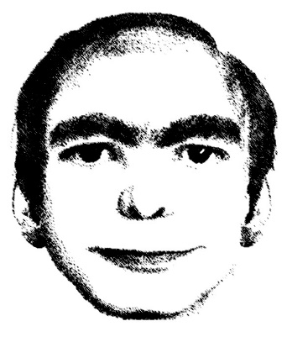

This man has allegedly been dreamt by thousands of people across the world. “Sightings” are not exclusive to western culture, as reports from “Sao Paulo, Tehran, Beijing…” are said to exist. The old website design is extremely simple, with plain white backgrounds, sans-serif fonts (probably Arial or Helvetica), a simple vertical nav bar, and very few interactive features. It does have a contact us javascript and some well-organized photo galleries, but that’s about it. The new website, the site you’ll find at thisman.org, retains the plain white background and sans-serif text throughout. However, it now boasts horizontal and vertical nav bars, a feed from their Facebook page, and some banners/borders for decoration. The contact page now also requires the user to solve a CAPTCHA, and no longer has a placeholder text for the user’s message. According to the VICE article, “it (the website) is really good! IT’s also entirely made up and fake.” It links to Knowyourmeme.com for more information, claiming the hoax was inspired by “the grand European tradition of groups like the Situationists.” To Natella’s credit, he went out of his way to avoid making a site that *looked* like it was a conspiracy theory. No warnings of impending doom, no grim (or overly cheerful) design choices, and no suspicious URL names. It even has a .org domain name!

Competitor 3: DHMO.org.

In terms of internet hoaxes, DHMO might be one of the most famous. It is a perfect example of the Dunning-Kruger effect, where people assume third party credibility when their own knowledge is lacking. “This person sounds like they know what they’re talking about, what reason have they given to *not* believe them?” Loading DHMO.org presents the reader with what a government or academic website might have looked like 15-20 years ago. Lots of science jargon, acronyms, and even a seal from the “United States Environmental Assessment Center.” Once again, a website designed not to look like a place for conspiracy theories. However, the truth is much simpler, and reveals a very well thought out joke. “Dihydrogen Monoxide” is the written chemical formula for water. Every bit of information about how dangerous DHMO is was presented to make it sound that way. Nowhere would it say that “DHMO is required for life,” as this would contradict all other claims about its danger. To enhance their credibility, the author has linked sites to actual organizations; however, they usually just go to their homepage. This would be like citing CNN for a paper but having “CNN.com” in the citation. Those who are so inclined would find it suspicious, but those who take it at face value are tricked. In terms of actual web design, DHMO has a simple gradient background, predominantly serif text, and an easy to follow site layout. If you don’t get overwhelmed by the number of links, you’ll see it has a nice 3 column home page. The main downsides are the fuzziness of its graphics, perhaps not noticed in a time of 4:3 resolution and CRT monitors. The site also has an odd max width of around 925 pixels, but I can’t find a clear mention to it in the source code. The closest is the width of the 3-column table, which is 729 pixels. The left and right banners are probably what give it the extra width. Why have a max width option instead of just adjusting to the size of the browser window?

Diagram (see end of document)

I couldn’t find a blank diagram on the Canvas page or any of the final project files. There was one project file that I didn’t have access to, maybe it was under there. I’ve attached a rough working diagram I created as part of assignment 5, which I’m still working on. I made a few changes to it to update names, but the 6-branch hierarchy remains.

Wireframe (see end of document)

I’ll include a few notes for my rationale on the wireframe. Firstly, big thanks to app.diagrams.net and their wireframe preset for speeding up the process.

In general, the wireframe is meant to be read from the middle of the page (in terms of width) and outward. I did my best to divide it into 3 sections, with most of the meat in the middle section. This is what the mobile version will look like, so not including the sidebars. I haven’t fully decided what purpose the sidebars will have. I’d like to implement a news feed, such as from a Facebook or Twitter account, but that might be more difficult than I’m expecting. If that doesn’t work, a static list of other fictious partners and “credible” news sites will work too. In the tablet/medium display, the middle and right columns will appear. The right column will have an option to show the “important news” column OR the “our partners” column. (Replace these titles with whatever ends up going in these columns, remember, they’re just placeholders for now). Finally, the full display will resemble the wireframe in its entirety. The tablet and desktop versions will also have more interactivity, as I’ve hinted in the hero image text.

For reference, here’s the wireframe proposal compared to what I’ve coded so far.

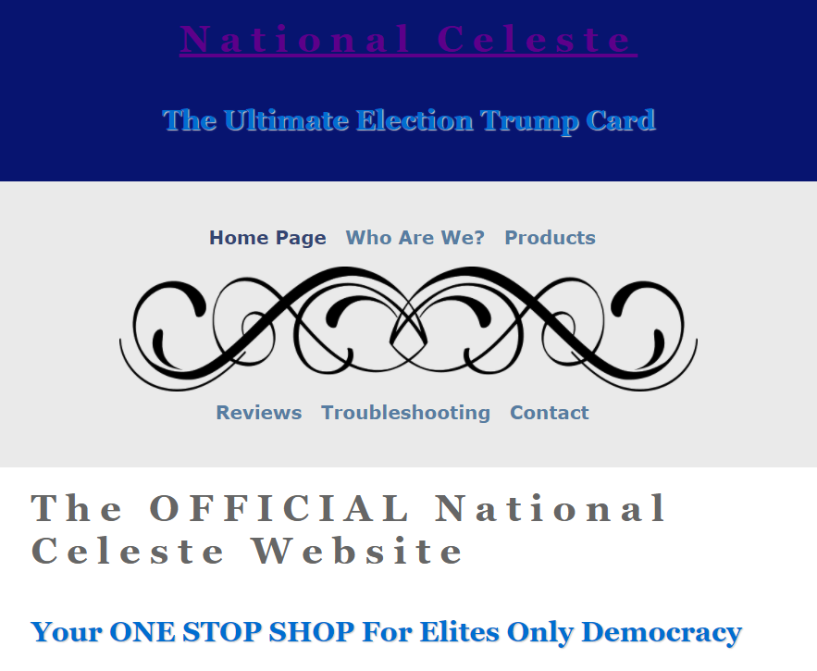

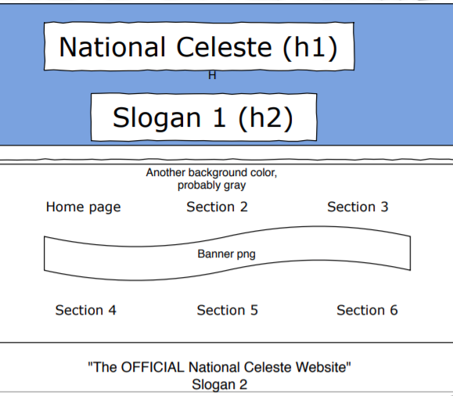

Images and Text

I’ve already gone into some detail about using images and text, but I haven’t given a bigger picture yet. I’m hoping to get the bland, sterile feeling you get from corporate websites. Pictures of forced smiles and/or work environments, overly verbose descriptions, and painfully boring graphics. Interactivity will be reserved to a simple slideshow, contact us javascript, and maybe a few more things. We’ll see.

Not entirely related, and I believe I’ve already cited this video in an assignment for this class, but I strongly recommend watching this: <https://bit.ly/336wVKL>

CSS, Interactivity, Etc.

Anything else that didn’t fit into the above categories. The biggest challenge will be having a variable grid for the tablet display, allowing the user to choose from the “our partners” or “important news” column. Another option would be to just have this on a timer, but that only removes the viewer’s input aspect. I’d still have to code it shifting from one column to the other. This should cover the new skills category, especially if I follow through with the Facebook/Twitter feed idea I mentioned earlier.

I’m going to stick to plain or “boring” color schemes, serif fonts (except for hyperlinks,) and a generally boring taste. A sort of “I put fade in/out transitions in my PowerPoint only because you told me to” tier quality.

“National Celeste” is an anagram for “Steal an election.” I found it with (I believe) this website while trying to come up with a verbose name that said almost nothing about the company and yet carried a hidden meaning. Celeste is from a Latin word for heavenly; one place you may have heard it used is to refer to “celestial objects.”